

TRIBHUVAN UNIVERSITY
INSTITUTE OF ENGINEERING
THAPATHALI CAMPUS

A Minor Project Midterm Report
On
PNEUMOTHORAX SEGMENTATION FROM CHEST X-RAY
USING DEEP CONVOLUTIONAL NETWORKS

Submitted By:
Aashish Chapain (THA075BCT002)
Ashok Budha (THA075BCT013)
Bibek Khanal (THA075BCT016)
Kapil Shrestha (THA075BCT022)

Submitted To:
Department of Electronics and Computer Engineering
Thapathali Campus
Kathmandu, Nepal

December, 2021

ACKNOWLEDGEMENT
We would like to express our sincere thanks to Er. Kiran Chandra Dahal, HOD Department of Electronics and Computer Engineering, Thapathali Campus for providing this opportunity. We are deeply grateful to Er. Umesh Kanta Ghimire, Deputy Head (Electronics) and Er. Rama Bastola, Deputy Head (EMIS), and entire team of Department of Electronics and Computer Engineering, Thapathali Campus for their continuous and constructive critique in research and study for the preparation of this proposal. Without their guidance this proposal would not have been possible. We express our sincere gratitude to our supervisor Er. Himal Chand Thapa sir for his guidance and assistance in selecting and refining our objectives regarding the project proposal. This journey would not have been possible without the sheer support of our classmates, friends, family members. We would like to acknowledge their encouragement and support.
Aashish Chapain (THA075BCT002)
Ashok Budha (THA075BCT013)
Bibek Khanal (THA075BCT016)
Kapil Shrestha (THA075BCT022)

ABSTRACT
Pneumothorax commonly known as collapsed lung is a fatal disease which occurs when air enters the pleural space, the area between the chest wall and the lung. Air when it goes into the pleural space builds up the pressure against the lung, causing it to collapse partially or fully. The primary method of diagnosis of pneumothorax is chest X-ray imaging. A radiologist or a certified physician is needed to segment the affected part from X-ray image. Pneumothorax is found to be difficult to segment out from X-ray image even for a certified surgeon or radiologist. In these kind of scenarios computer vision has shown promising results for segmentation. So, we propose to use SegNet, UNet and UNet++ (a machine learning architecture which has been used for medical imaging) to predict and analyze the accuracy from different models.
Keywords: Pneumothorax, computer vision, SegNet, UNet, UNet++

Table of Contents

ACKNOWLEDGEMENT ii
ABSTRACT iii
List of Tables viii
List of Abbreviations ix
1. INTRODUCTION 1
1.1 Background 1
1.1.1 Image Segmentation 1
1.1.2 Convolutional Neural Network (CNN) 2
1.1.2.1 Convolutional layer 2
1.1.2.2 Pooling layer 2
1.1.2.3 Fully connected layer 2
1.1.2.4 Dropout 3
1.1.2.5 Batch Normalization 3
1.2 Motivation 3
1.3 Problem Definition 3
1.4 Problem Objectives 3
1.5 Project Scope and Applications 4
2. LITERATURE REVIEW 5
3. REQUIREMENT ANALYSIS 8
3.1.1 Hardware Requirement: 8
3.1.2 Software Requirement: 8
3.1 PROJECT REQUIREMENT 9
3.2 FEASIBILITY ANALYSIS 9
3.2.1 Technical Feasibility 9
3.2.2 Financial Feasibility 9
3.2.3 Schedule Feasibility 9
3.2.4 Operational Feasibility 9
4. DATASET ANALYSIS 10
5. SYSTEM ARCHITECTURE AND METHODOLOGY 11
5.1 Process Flow 11
5.2 Data Sources 12
5.3 Data Processing and Augmentation 12
5.4 Applied Architecture 12
5.4.1 U-Net architecture 12
5.4.2 U-Net++ Architecture 14
5.4.3 SegNet architecture 15
5.5 Semantic Segmentation 16
5.6 Evaluation Metrics 16
6. IMPLEMENTATION 17
6.1 Data Collection and Preprocessing 17
6.2 Implementing a Deep learning Model 18
7. RESULT AND ANALYSIS 20
8. REMAINING TASKS 21
9. APPENDICES 22
9.1 PROJECT SCHEDULE 22
9.2 Code Snippets 22
References 28

List of Figures
Figure 5-1: Proposed flow diagram of project ------------------------------ 11
Figure 5-4-1-1: Legends for the following graph fig 5-4-1-2 ------------------ 13
Figure 5-4-1-2: UNET Architecture ----------------------------------------------- 14
Figure 5-4-2: Representation of U-Net++ Architecture ---------------------- 15
Figure 5-4-3: Representation of SegNet Architecture ----------------------- 15
Figure 5-5: Semantic Segmentation for Pneumothorax Segmentation -- 16
Figure 6-1: Images After Applying data augmentation techniques ------- 17
Figure 6-2-1: UNET Architecture ----------------------------------------------- 18
Figure 6-2-2: Legends for the above graph ------------------------------------ 18
Figure 7-1: Plotting of epoch vs. Dice Metric ------------------------------- 18
Figure 7-2: Plotting of loss vs. no. of epoch --------------------------------- 18

List of Tables
Table 9-1: Gantt Chart ---------------------------------------------------------------------- 22

List of Abbreviations
AI Artificial Intelligence
CAD Computer Aided Diagnosis
CNN Convolutional Neural Networks
CT Scan Computed Tomography Scan
CUDA Compute Unified Device Architecture
FCN Fully Connected Networks
GPU Graphics Processing Unit
MRI Magnetic Resonance Imaging
PC Personal Computer
SIIM Society for Imaging Informatics in Medicine
UI User Interface

INTRODUCTION

Background
Artificial Intelligence has ruled the progress of today's era. Artificial Intelligence is the simulation of human intelligence processes by machines, especially computer systems. AI system tend to work by ingesting large amounts of labeled or unlabeled training data, analyzing the data for correlations and patterns, and using these patterns to make predictions about future states. It has been able to revolutionize the fields ranging from agriculture, transportation, manufacture, analytics, security to self-driving cars, natural language recognition and automated robots which seemed to be impossible to implement not more than few decades ago. The current trend of development of AI has also been able to revolutionize medical field. AI based innovations or models have been able to diagnose fatal diseases like cancer, breast cancer, diabetic retinopathy, etc. and help avoid them efficiently.
A.I. based medical image segmentation is one of the rapidly developing fields in the machine learning industry. This report addresses about one of such problems associated with segmentation and classification of pneumothorax affected lungs using chest X-rays. Pneumothorax is one of the most dangerous and hard to diagnose health condition. It can be predicted conventionally (i.e. from observation of chest X-ray) but even the best of medical professionals have hard time to detect pneumothorax. Current researches have shown that AI based deep learning neural networks can be used for medical image segmentation in cases like Pneumothorax. Segmentation models like Unet, Unet++, ResNet are some of the models that have significantly improved the medical image segmentation process to find out the affected part of human body from imaging like X-Ray, MRI, CT-Scan.

1.1.1 Image Segmentation
In digital image processing and computer vision, image segmentation is the process of partitioning a digital image into multiple image segments, also known as image regions or image objects (sets of pixels). The goal of segmentation is to simplify and/or change the representation of an image into something that is more meaningful and easier to analyze. Image segmentation is typically used to locate objects and boundaries (lines, curves, etc.) in images. More precisely, image segmentation.
The result of image segmentation is a set of segments that collectively cover the entire image, or a set of contours extracted from the image (see edge detection). Each of the pixels in a region are similar with respect to some characteristic or computed property, such as color, intensity, or texture. Adjacent regions are significantly different color respect to the same characteristic(s).

1.1.2 Convolutional Neural Network (CNN)
CNN is a class of artificial neural network. CNN provide superior performance with image, speech, or audio signal. CNNs are version of multilayer perceptron, fully connected networks. CNNs use relatively little pre-processing compared to other image classification algorithm. They have three main types of layers which are:
- Convolutional layer
- Pooling layer
- Fully connected layer

1.1.2.1 Convolutional layer
Convolutional layer is the core building block of a CNN. Majority of computation occurs in this layer. It requires a few components, which are input data, a filter, and a feature map. In this layer, scalar product is done between all part of input data and the filter matrix to get the output array. Value of filter matrix describes which feature of input is to be conserved and compared.

1.1.2.2 Pooling layer
Pooling layers reduces the number of parameters from the input. It is also known as down sampling. There are two types of pooling: max pooling; it selects the pixel with maximum value to send to output array, and average pooling; it calculates the average within the receptive field to send to the output array.

1.1.2.3 Fully connected layer
Each node of output layer connects directly to a node in the previous layer. This layer performs the task of classification based on features extracted through the previous layers and their different filters. FC layers uses activation function to classify inputs appropriately.

1.1.2.4 Dropout
At each training stage, individual nodes are either dropped out of the net with probability 1-p or kept with probability p, so that a reduced network is left; incoming and outgoing edges to a dropped-out node are also removed.

1.1.2.5 Batch Normalization
Batch normalization is a technique for training very deep neural networks that standardizes the inputs to a layer for each mini-batch. This has the effect of stabilizing the learning process and dramatically reducing the number of training epochs required to train deep networks.

1.2 Motivation
The major motivation for us to research in this topic was from a Kaggle competition conducted in 2020 with a winning prize of $50,000. Upon eying a glace in this topic,we found out that the condition was a severe competition and the segmentation was found to be difficult job even for experts which motivated us for this research.

1.3 Problem Definition
Pneumothorax is a fatal disease which can occur to any age group of adults without any significant reason and the rate of death from Pneumothorax is 1.26 per million a year for men and 0.62 per million a year for women. It can be life threatening if not diagnosed and treated in time. Currently the only way of diagnosing is X-ray of chest and manual segmentation is very difficult even for expert individuals. So, we try to implement a deep learning model to segment the chest X-rays to isolate and identify the Pneumothorax affected regions

1.4 Problem Objectives

- To classify the Pneumothorax affected X-rays with reasonably high accuracy.
- To segment the Pneumothorax affected part from the given X-ray images.
- To provide intuitive User Interface (UI) for classifying and segmenting provided X-rays.

1.5 Project Scope and Applications
- Used by medical professionals to segment the affected part from X-ray.
- Used by patients to find out affected part in absence of expert.

LITERATURE REVIEW
Many researches are being done in the field of medical imaging using AI in past few years. The medical field is being upgraded. Digital image processing has been widely applied in the medical domain. However, most of the methods still require manual processing. Automatic image segmentation and features analysis can assist doctors in the treatment and diagnosis of diseases with higher accuracy. The computer aided diagnosis (CAD) has the potential for improving the diagnostic accuracy of radiologists to distinguish between pneumothorax and other conditions. Most of the previously done researches were developed for the diagnosis of the chest radiograph which was insufficient for medical proposes. Nowadays, many researchers are focused on the image segmentation and detection for diseased location which is the main propose of our project.
According to the research done by the researchers of United States, pneumothorax is prevalently occurring in humans, and its relapse ratio is 35% in men [1]. Critical pneumothorax may lead to hypoxia, shock, and even death. Currently, chest scans are used to diagnose pneumothorax. Chest radiograph scans the whole chest and produces abundant information and radiologists have to review the data [2]. Chest X-ray images should be processed before feeding into our model and it will predict whether a person is suffering from pneumothorax or not. Not only this, our model also segments the affect region of lungs and give a mask as output so that doctor could know which area is problematic.
Convolutional Neural networks have been revolutionary in the field of image recognition and classification in the decades of 2020's even though they were discovered in the 1980s. The computational power and resources at that time did not help further advancement in this field [9]. With the increase in computational power in this decade, CNNs have been a go to solution in every kind of classification and recognition tasks. ConvNets are not only improving for whole image classification but also making progress on local tasks with structured outputs which includes bounding box object detections and key point prediction [3].
With the use of ConvNets in local bounding box detection, it was natural to make progression in pixel wise prediction which lays the foundation of current day image segmentation [4]. Image classification task involved relatively fewer no. of fully connected layers for classification task whereas segmentation possesses a huge problem since the output involves per pixel classification of images. Therefore, fully convolutional Network (FCN) [4] was better suited for this task.
Fully convolutional networks are neural networks which doesn't consist of a fully connected layer within it as specified by Saber et.al. [5]. Fully convolutional networks (FCN) can learn efficiently to make dense predictions for per-pixel tasks which makes it suitable for the tasks like semantic segmentation. SegNet [8], U-Net [6], U-Net++ [7] and SegNet [8] are some of the examples of FCN with some of the improvements introduced throughout the time.
SegNet [8] is one of the examples of FCN. It follows simple encoder decoder model. SegNet has an encoder network and a corresponding decoder network followed by a final pixel-wise classification layer. Each of encoder layer has an exact corresponding decoder layer as shown in the figure 4.4.
U-Net is an extension of a fully connected networks that can work effectively with unbalanced datasets with very few training images and yields more precise segmentations. The architecture of U-Net has a contracting path and an expansive path as shown in the figure 4.2. At each down sampling step, we double the number of feature channels. In every up-sampling step, we halve the no. of feature channels. Skip connections are introduced to make up for the lost features and information during the up-sampling process [6]. The exceptional performance of U-Net has made it a popular choice among the researcher in biomedical image segmentation.
Unet architecture uses different operations before giving final output. Mainly it uses Convolution operation, max pooling and Transposed convolution [10]. There are two inputs to a convolutional operation:
- Input image
- Kernels
The function of the max pooling is to reduce the size of the feature map so that we have fewer parameters in the network. The idea is to retain only the important features from each region and throw away the information which is not important. A very important point to note here is that both operation and specially the pooling operation reduce the size of the image. This is called down sampling. By down sampling, the model better understands “WHAT” is present in the image, but it loses the information of “WHERE” it is present [10].
Transposed convolution (sometimes also called as deconvolution or fractionally stride convolution) is a technique to perform up sampling of an image with learnable parameters [10].
Both FCNs and U-Net share a key idea of skip connections. In FCN [5], up sampled feature maps are summed with feature maps skipped from encoder, while U-Net [6] concatenates them and adds convolutions and non-linearities between each up-sampling step [7]. As shown by the figure 4.3, U-Net++ consists of nested U-Net architectures. U-Net++ differs from the original U-Net in three ways: 1) having convolution layers on skip pathways 2) having dense skip connections on skip pathways which improves gradient flow and 3) having deep supervision. We propose to use U-Net++ as our primary model and compare the performance of U-Net++ with the performance of U-Net, SegNet and traditional FCNs.

REQUIREMENT ANALYSIS

3.1.1 Hardware Requirement:

PC with high processing capability, high performance GPU and at least 8 GB RAM are necessary. The internal storage or disk required is at least 40 GB.

3.1.2 Software Requirement:

- Python: Python is a high level language developed for mathematical applications and fast paced problem solving.
- Google Collab : Google Collab is a cloud based computational platform developed by Google specially for training machine learning models.
- Tensor flow: Tensorflow is a framework based on Python and Javascript. It provides helpful tools for designing and implementing machine learning models.
- Keras: Keras is a library that runs on the backend of Tensorflow. It provides intuitive tools for machine learning model designs.
- OpenCV: OpenCV is Python based library that provides tools for working with image files.
- Numpy: Numpy is a library that can be used in Python to implement mathematical formulations and data cleaning mechanism.
- Pandas: Pandas is a library that is used for handling large amount of databases and its mathematical manipulations.
- Django: Django is a python based web framework which is used to develop fast and robust web applications in short time.

3.1 PROJECT REQUIREMENT

3.2 FEASIBILITY ANALYSIS
A feasibility study is utilized to decide the practicality of an idea, such as ensuring a project is legally and technically feasible as well as economically justifiable.

3.2.1 Technical Feasibility
In the hardware department, we need a well-functioning GPU (Graphical Processing Unit) to carry out the training process and in the software department, we will be using Python, VS Code and CUDA library.

3.2.2 Financial Feasibility
Our project is economically feasible since we will be using Google Collab for the project. So, our project can be completed without any cost.

3.2.3 Schedule Feasibility
The project will be completed within the allocated time as presented by the Gantt-Chart in table 6.

3.2.4 Operational Feasibility
The project will be able to solve the needs of end users who are medical professionals, doctors and patients. It will be easily applicable as it will be provided with interactive UI.

DATASET ANALYSIS
The dataset used for this project was obtained from Kaggle which was hosted by SIIM as a part of the research and competition. The dataset consisted of 12,400 training datasets which was further divided into training sets, validation dataset and test data set. The dataset was highly imbalanced as it consisted of about 2500 Pneumothorax affected X-rays while the rest of them were not affected X-rays. Due to this reason the dataset was highly imbalanced and further required several processes to balance the data. The current graph shown below shows the distribution of affected and not affected X-rays from the given dataset.

SYSTEM ARCHITECTURE AND METHODOLOGY

5.1 Process Flow

Data Collection
Data pre-processing
Model Design
Model Testing
Hyper-parameter tuning
Model Evaluation
Metrics Comparison

Fig. 5-1 Proposed flow diagram of Project

5.2 Data Sources
- Primary Sources: - No primary sources were involved in data collection.
- Secondary Sources: - The data set of pneumothorax affected X-rays were obtained from SIIM (Society for Imaging Informatics in Medicine) website which was hosted in Kaggle.com.

5.3 Data Processing and Augmentation

The data set for the segmentation and classification of pneumothorax was obtained from Kaggle. The data set consisted of large ratio of chest x-rays unaffected with pneumothorax and small ratio of chest x-rays affected with pneumothorax. The ratio of pneumothorax affected and unaffected chest x-rays were balanced to prevent over fitting. Various position augmentation techniques like cropping, flipping, rotation, translation and color augmentation techniques like brightness, contrast, saturation, and hue were used to increase the data set size.

Applied Architecture
5.4.1 U-Net architecture
We proposed to use UNET for classification and segmentation. UNET is one of the leading models that has shown a promising result with very high accuracy for biomedical image segmentation. Comparing with the conventional convolutional neural networks UNET uses encoder and decoder type model with long skip connections between them to prevent gradient explosion and information loss. Conventional CNN’s suffer from vanishing gradient which is a case in which the weight of the model attain a very small value. As more layers using certain activation functions are added to neural networks, the gradients of the loss function approaches zero, making the network hard to train. Therefore the long skip connection in the UNET model helps to preserve the fine-grain details during segmentation and makes the model easier to train.

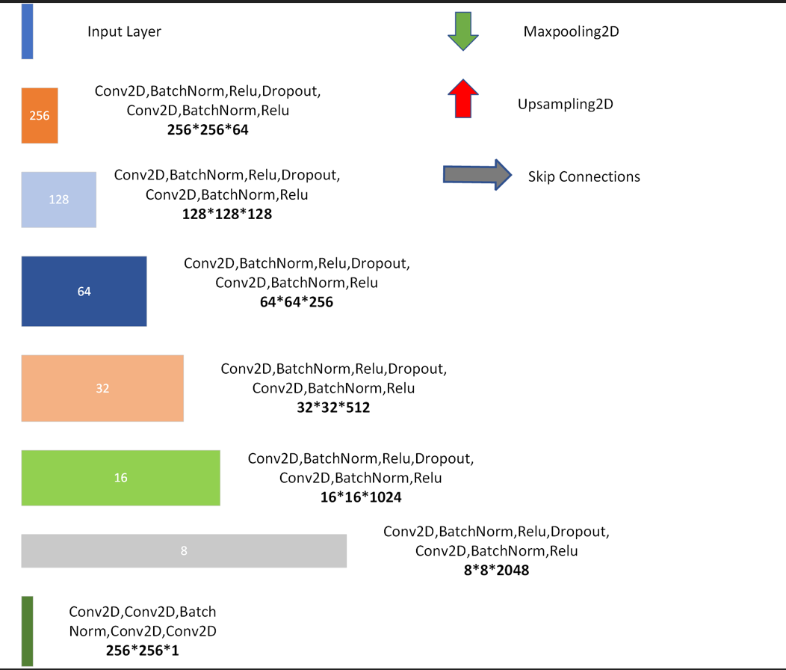

Fig. 5-4-1-1 Legends for the following graph fig. 5-4-1-2

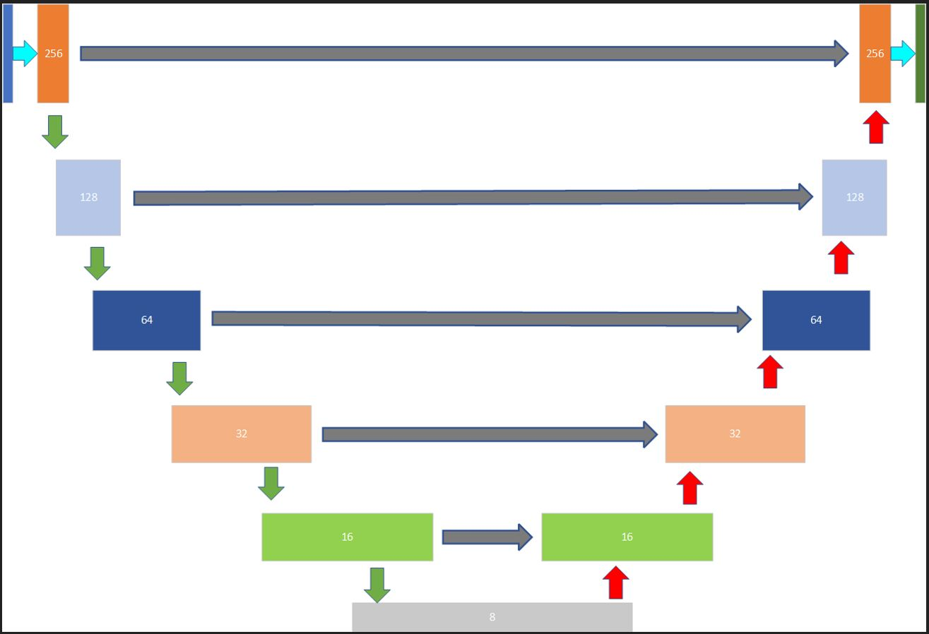

Figure 5-4-1-2 UNET Architecture

5.4.2 U-Net++ Architecture
U-Net++ consists of nested U-Net architectures. U-Net++ differs from the original U-Net in three ways: 1) having convolution layers on skip pathways 2) having dense skip connections on skip pathways which improves gradient flow and 3) having deep supervision. It is represented as follows:
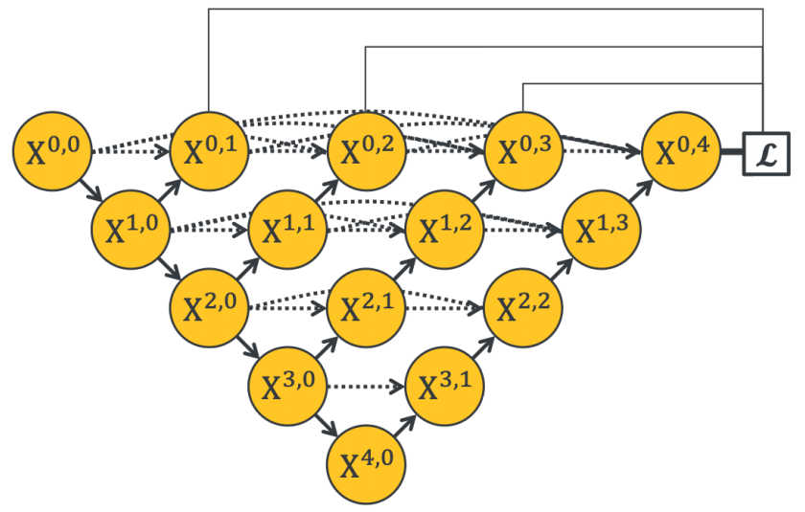
Figure 5-4-2 Representation of U-Net++ Architecture

5.4.3 SegNet architecture
SegNet is one of the examples of FCN. It follows simple encoder decoder model. SegNet has an encoder network and a corresponding decoder network followed by a final pixel-wise classification layer. Each of encoder layer has an exact corresponding decoder layer as shown in the figure 4.4. The architecture is represented as follows
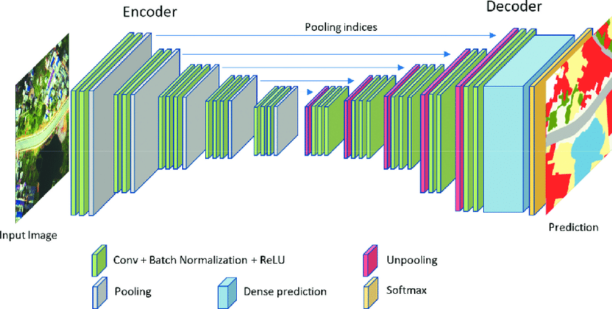
Fig. 5-4-3 Representation of SegNet architecture

5.5 Semantic Segmentation
Semantic segmentation is a task of assigning a class label to every pixel in the image. The goal of semantic image segmentation is to label each pixel of an image with a corresponding class of what is being represented. Because we’re predicting for every pixel in the image, this task is commonly referred to as dense prediction. Pneumothorax is one of the best candidate for semantic segmentation task. The primary diagnosis of pneumothorax are done using x-ray imaging. UNET or any other models can be used to accomplish this task at a very reasonably high accuracy.
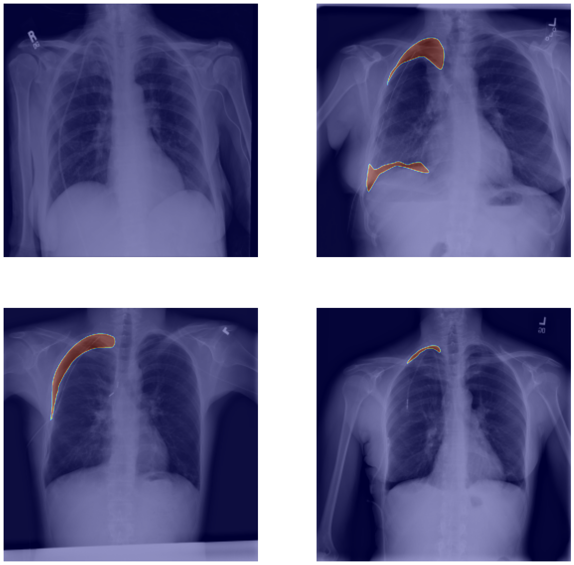

Fig. 5-5 Semantic Segmentation for Pneumothorax segmentation

5.6 Evaluation Metrics

Evaluating the segmentation task is very difficult. There exist no standard defined rules to evaluate a segmentation model. Since it has been an active field of research there are many methods that have been proposed for evaluation. Some of them are IoU, Dice-Coefficient, Pixel Accuracy etc. IoU and Dice coefficient are some of the current best choices for evaluating the segmentation models. Most of the state of the art models use these metrics to evaluate the model performance. Therefore, we have considered using these same for evaluating our model too.

Dice Coefficient = $\frac{2|XꓵY| }{\left|X\right|+|Y|}$ IOU = $\frac{|XꓵY| }{|X∪Y|}$
where x is predicted output and y is ground truth.

IMPLEMENTATION

6.1 Data Collection and Preprocessing
We used dataset provided to us by SIIM which was hosted by Kaggle as a part of competition which was held in 2015 A.D. for research purposes. We were provided with more than 12,000 images to deal with. Upon studying the nature of data we found that the data was highly imbalanced as specified in chapter 4 dataset analysis. Fig .4.1 shows the distribution of the data before balancing whereas fig. 4.2 shows the distribution of data after balancing the dataset.
We applied data augmentation process to fabricate the dataset as the dataset was relatively small in number compare to average machine learning datasets. We used tensorflow data augmentation pipeline which consisted of central crop, random brightness, random hue, random saturation and random contrast, flipping up-down, flipping left-right and using another library called elastic-deform.
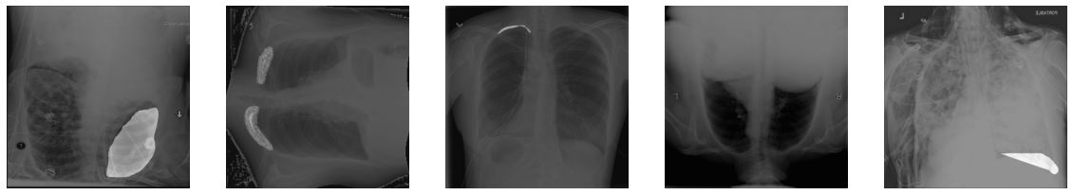
Figure 6-1 Images after applying data augmentation techniques
Since the quantity of data was quite large to train or load memory at once, the whole dataset was broken down into no. of batches. In our case, we divided it into batches of 8 so that we could load it into memory without crashing it.

6.2 Implementing a Deep learning Model

Figure: 6-2-1 U-Net architecture
A deep learning model is constructed as shown in the figure above. The legends of the above graph is presented in the figure below :

Figure: 6-2-2 Legends for the above graph
The above fig. 6.2.2 shows the U-Net model architecture which consists of a encoder and a decoder part. In case of encoder part, we have :-
- Input layer
- Conv2D layer
- Batch Normalization layer
- ReLU layer
- Dropout layer
In case of a decoder part, maxpool2D is replace by upsampling2D which helps to restore the image size as that of the input size finally.

RESULT AND ANALYSIS
We are able to provide evaluation metric i.e. dice metric upto 0.35. The dataset we’ve used in our project was imbalanced (affected = 2500 and not-affected = 9900). So, data processing was done but the accuracy is not good enough for our project. Further data processing and improvement of our project model can be done to increase our accuracy and result of our iou metric.
The graph of epoch vs dice-metric and epoch vs loss is given below:
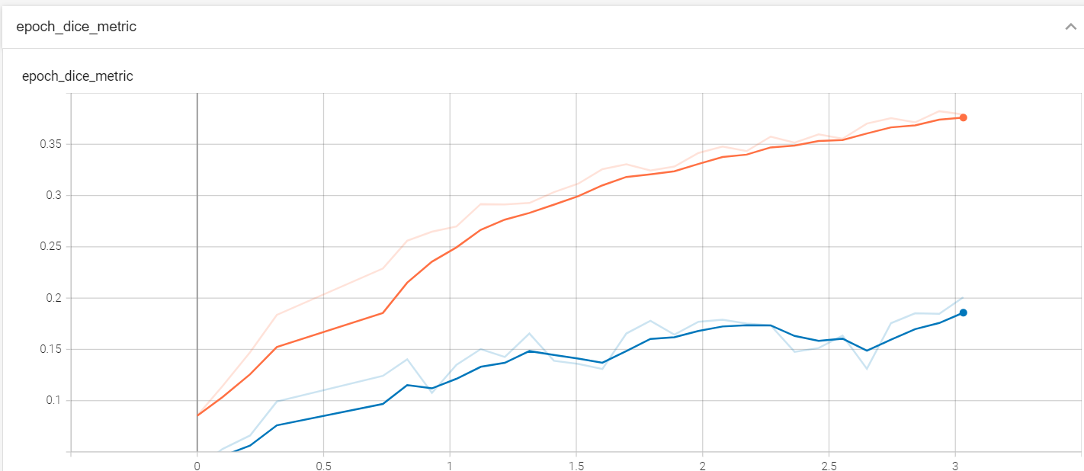

Figure 7-1 Plotting of epoch vs dice-metric
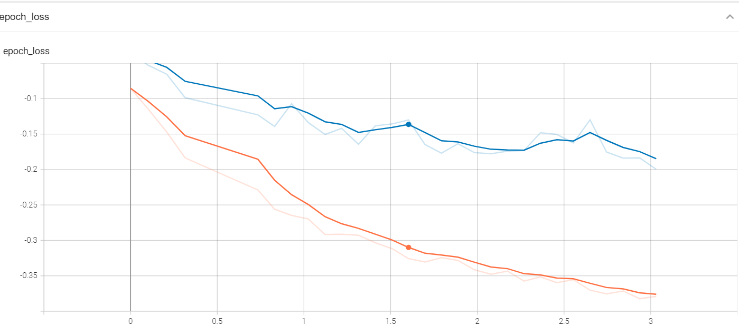
Figure 7.2 epoch vs loss
As shown in the figure 7.1 dice-metric is increasing after each epoch and in the figure

Figure 7-2 Plotting of loss vs. no. of epoch.

REMAINING TASKS
The remaining tasks in our project are: -
- The model for classification tasks is designed but we have not yet completed the prediction part of the model.
- The designing of User Interface is not yet completed.
- The dice metric score can be vastly improved for the segmentation tasks.

APPENDICES

9.1 PROJECT SCHEDULE
Table 9.1: Gantt Chart

9.2 Code Snippets
Code Snippets for calculating dice focal loss
class dice_bce_focal_loss(tf.keras.losses.Loss):
def __init__(self, loss_type = 'sorensen', smooth=0.01, alpha=0.25, beta=0.75, gamma=0.25):
super(dice_bce_focal_loss, self).__init__()
self.loss_type = loss_type
self.smooth = smooth
self.alpha = alpha
self.beta = beta
self.gamma = gamma
def call(self, y_true, y_pred):
y_true_f = layers.Flatten()(y_true)
y_pred_f = layers.Flatten()(y_pred)
intersection = tf.reduce_sum(y_true_f * y_pred_f)
if self.loss_type == 'jaccard':
union = tf.reduce_sum(tf.square(y_pred_f)) + tf.reduce_sum(tf.square(y_true_f))
elif self.loss_type == 'sorensen':
union = tf.reduce_sum(y_pred_f) + tf.reduce_sum(y_true_f)
else:
raise ValueError("Unknown `loss_type`: %s" % self.loss_type)
# binary cross entropy
bce = tf.keras.losses.BinaryCrossentropy()
focal = tfa.losses.SigmoidFocalCrossEntropy()
dice_value = ((2.0 * intersection + self.smooth) / (union + self.smooth))
bce_value = bce(y_true, y_pred)
focal_value = focal(y_true, y_pred)
total_loss = self.alpha * dice_value + self.beta * bce_value + self.gamma * focal_value
return total_loss
class dice_loss(tf.keras.losses.Loss):
def __init__(self):
super(dice_loss, self).__init__()
def call(self, y_true, y_pred):
total_loss = -dice_metric(y_true, y_pred)
return total_loss

Code Snippets for calculating IoU and Dice Metrics
def IoU(y_true, y_pred, smooth=0.1):
intersection = K.sum(K.sum(K.abs(y_true * y_pred), axis=-1))
sum_ = K.sum(K.sum(K.abs(y_true) + K.abs(y_pred), axis=-1))
jac = (intersection + smooth) / (sum_ - intersection + smooth)
return (1 - jac) * smooth
def dice_metric(y_true, y_pred):
y_true = K.cast(y_true, K.floatx())
y_pred = K.cast(y_pred, K.floatx())
intersection = K.sum(K.sum(K.abs(y_true * y_pred), axis=-1))
union = K.sum(K.sum(K.abs(y_true) + K.abs(y_pred), axis=-1))
# if y_pred.sum() == 0 and y_pred.sum() == 0:
# return 1.0
return 2*intersection / union

Code Snippets for creating U-Net model
def get_unet_model(img_size, num_classes, channel, pretrained=False, model_checkpoint_path=None):
inputs = Input(shape=img_size + (channel,))
filters = [64, 128, 256, 512, 1024, 2048]
x = SeparableConv2D(filters[0], 3, padding='same')(inputs)
x = BatchNormalization()(x)
x = relu(x)
x = Dropout(0.1)(x)
x = SeparableConv2D(filters[0], 3, padding='same')(x)
x = BatchNormalization()(x)
conv1 = relu(x) # 256
x = MaxPooling2D(3, strides=2, padding="same")(x)
x = SeparableConv2D(filters[1], 3, padding='same')(x) # 128
x = BatchNormalization()(x)
x = relu(x)
x = Dropout(0.1)(x)
x = SeparableConv2D(filters[1], 3, padding='same')(x)
x = BatchNormalization()(x)
conv2 = relu(x) # 128
x = MaxPooling2D(3, strides=2, padding="same")(x)
x = SeparableConv2D(filters[2], 3, padding='same')(x) # 64
x = BatchNormalization()(x)
x = relu(x)
x = Dropout(0.2)(x)
x = SeparableConv2D(filters[2], 3, padding='same')(x)
x = BatchNormalization()(x)
conv3 = relu(x) # 64
x = MaxPooling2D(3, strides=2, padding="same")(x)
x = SeparableConv2D(filters[3], 3, padding='same')(x) # 32
x = BatchNormalization()(x)
x = relu(x)
x = Dropout(0.2)(x)
x = SeparableConv2D(filters[3], 3, padding='same')(x)
x = BatchNormalization()(x)
conv4 = relu(x) # 32
x = MaxPooling2D(3, strides=2, padding="same")(x)
x = SeparableConv2D(filters[4], 3, padding='same')(x) # 16
x = BatchNormalization()(x)
x = relu(x)
x = Dropout(0.3)(x)
x = SeparableConv2D(filters[4], 3, padding='same')(x)
x = BatchNormalization()(x)
conv5 = relu(x) # 16
x = MaxPooling2D(3, strides=2, padding="same")(conv5)
x = SeparableConv2D(filters[5], 3, padding='same')(x) # 8
x = BatchNormalization()(x)
x = relu(x)
x = Dropout(0.3)(x)
x = SeparableConv2D(filters[5], 3, padding='same')(x)
x = BatchNormalization()(x)
x = relu(x) # 8
# up sampling
x = UpSampling2D(size=(2, 2))(x) # 16
x = Conv2DTranspose(filters[4], 3, padding='same')(x) # 16
x = concatenate([conv5, x])
x = Conv2DTranspose(filters[4], 3, padding='same')(x) # 16
x = BatchNormalization()(x)
x = relu(x)
x = Dropout(0.3)(x)
x = Conv2DTranspose(filters[4], 3, padding='same')(x)
x = BatchNormalization()(x)
x = relu(x)
x = UpSampling2D(size=(2, 2))(x)
x = Conv2DTranspose(filters[3], 3, padding='same')(x) # 32
x = concatenate([conv4, x])
x = Conv2DTranspose(filters[3], 3, padding='same')(x) # 32
x = BatchNormalization()(x)
x = relu(x)
x = Dropout(0.2)(x)
x = Conv2DTranspose(filters[3], 3, padding='same')(x)
x = BatchNormalization()(x)
x = relu(x)
x = UpSampling2D(size=(2, 2))(x)
x = Conv2DTranspose(filters[2], 3, padding='same')(x) # 32
x = concatenate([conv3, x])
x = Conv2DTranspose(filters[2], 3, padding='same')(x) # 32
x = BatchNormalization()(x)
x = relu(x)
x = Dropout(0.2)(x)
x = Conv2DTranspose(filters[2], 3, padding='same')(x)
x = BatchNormalization()(x)
x = relu(x)
x = UpSampling2D(size=(2, 2))(x)
x = Conv2DTranspose(filters[1], 3, padding='same')(x) # 32
x = concatenate([conv2, x])
x = Conv2DTranspose(filters[1], 3, padding='same')(x) # 32
x = BatchNormalization()(x)
x = relu(x)
x = Dropout(0.1)(x)
x = Conv2DTranspose(filters[1], 3, padding='same')(x)
x = BatchNormalization()(x)
x = relu(x)
x = UpSampling2D(size=(2, 2))(x)
x = Conv2DTranspose(filters[0], 3, padding='same')(x) # 32
x = concatenate([conv1, x])
x = Conv2DTranspose(filters[0], 3, padding='same')(x) # 32
x = BatchNormalization()(x)
x = relu(x)
x = Dropout(0.1)(x)
x = Conv2DTranspose(filters[0], 3, padding='same')(x)
x = BatchNormalization()(x)
x = relu(x)
x = Conv2D(16, 3, padding='same')(x)
x = Conv2D(16, 3, padding='same')(x)
x = BatchNormalization()(x)
x = Conv2D(8, 1, padding='same')(x)
x = Conv2D(4, 1, padding='same')(x)
output_1 = Conv2D(num_classes, 1, activation='sigmoid',
name="segmentation_output")(x)
# Define the model
model = Model(inputs=inputs, outputs=output_1)
if pretrained:
model.load_weights(model_checkpoint_path)
return model

References
- C. Yuan-Hao et al., "Effective Pneumothorax Detection for Chest X-Ray Images Using Local Binary Pattern and Support Vector Machine", April 2018.
- J. Karan et al., "Pneumothorax Segmentation: Deep Learning Image Segmentation to predict Pneumothorax", April 2021.
- W. Lu et al., "An Improved Dice Loss for Pneumothorax Segmentation by Mining the Information of Negative Areas", August 2020.
- J. Long, E. Shelhamer, and T. Darrell, “Fully convolutional networks for semantic segmentation”, 2015 IEEE Conference on Computer Vision and Pattern Recognition (CVPR), 2015.
- S. Piramanayagam, E. Saber, W. Schwartzkopf, and F. Koehler, “Supervised classification of multisensor remotely sensed images using a deep learning framework,” Remote Sensing, vol. 10, no. 9, 2018.
- O. Ronneberger, “Invited talk: U-net convolutional networks for biomedical image segmentation,” Informatik aktuell, 2017.
- Z. Zhou, M. M. Rahman Siddiquee, N. Tajbakhsh, and J. Liang, “UNet++: A nested U-Net Architecture for Medical Image segmentation,” Deep Learning in Medical Image Analysis and Multimodal Learning for Clinical Decision Support, 2018.
- V. Badrinarayanan, A. Kendall, and R. Cipolla, “SegNet: A deep convolutional encoder-decoder architecture for image segmentation,” IEEE Transactions on Pattern Analysis and Machine Intelligence, vol. 39, no. 12, 2017.
- Y. LeCun, B. Boser, J. S. Denker, D. Henderson, R. E. Howard, W. Hubbard, and L. D. Jackel, “Backpropagation applied to handwritten zip code recognition,” Neural Computation, vol. 1, no. 4, 1989.
- Lamba, H., 2022. Understanding Semantic Segmentation with UNET. [online] Medium. Available at: <shorturl.at/otwIX> [Accessed 30 January 2022].

